MULTI-AGENTS SYSTEM PROJECT
Project 2 : COVID19 simulation

USER MANUAL

Installation of the project in Eclipse

To install my project, please follow the next instructions :
- Go to my GitHub repository: https://github.com/natachagrumbach/MASProject
- Download on your computer the source file directory : CovidSimulation
- Open Eclipse for Repast
- Create a new Repast Symphony project
- Name it "CovidSimulation"
- Open the Java perspective
- Copy all the source files located into CovidSimulation/src and paste them into the src directory created in your Repast project
- Copy all the xml files located into CovidSimulation/CovidSimulation.rs and paste them into the CovidSimulation.rs directory created in your Repast project (accept to overwrite all the files)
- Copy all the icon files located into CovidSimulation/icons and paste them into the icons directory created in your Repast project
- Click on the Run button and choose the CovidSimulation model
- Enjoy !

Execution
To run the Covid simulation, click on the Run button and choose the CovidSimulation model.
The following window is opened.

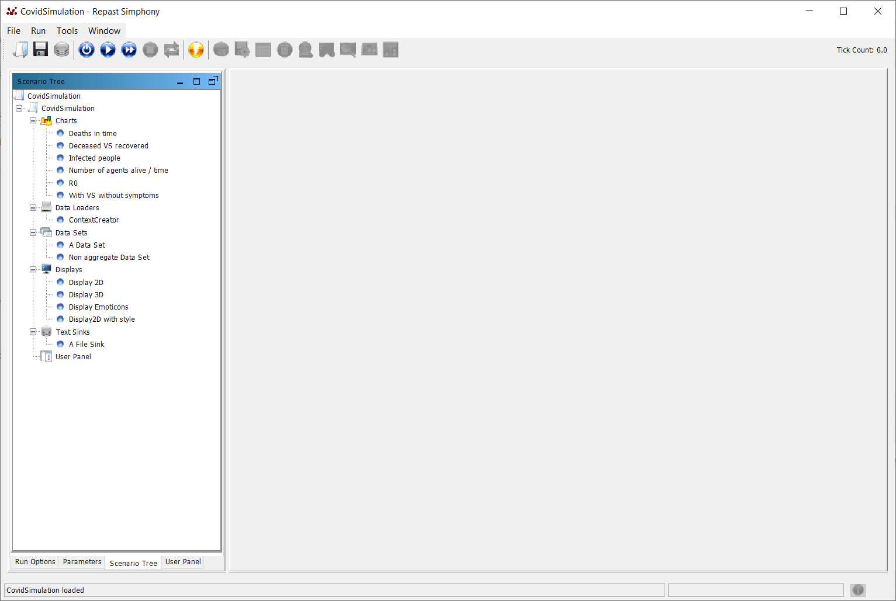
If you want to modify the speed of the simulation, click on the “Run Options” tab and use the slide of the “Schedule Tick Delay”.

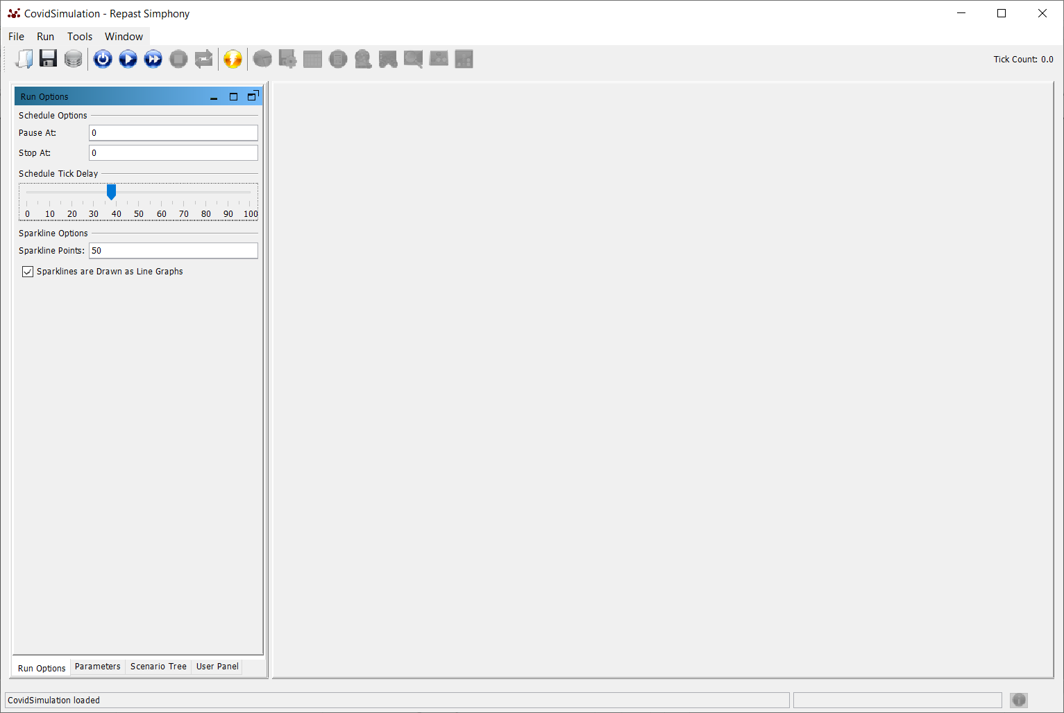
Then click on the “Parameters” tab and set the parameters of the simulation. The following table describes the different parameters.

Name | Description | Possible values | Default value
Grid height | Allows to set the height of the grid | Integer | 50
Grid width | Allows to set the width of the grid | Integer | 50
Name | Description | Possible values | Default value
Movement scenario | Selection of the movement scenario:  - either random : agents move in a random way;  - or attractive places : agents move towards attractive places | Random scenario  Attractive places | Random scenario
Number of infected agents | Sets the number of infected agents at the initialization. The created agents are symptomatics. | Integer | 1
Number of susceptible agents | Sets the number of susceptible agents at the initialization. | Integer | 400
Probability of being docile (wear the mask if mandatory) | This probability is used at the creation of the population of agents. If the mask strategy is activated, the created agent will wear the mask depending on this probability. | Float  (between 0 and 1) | 1
Probability of being elderly | This probability is used at the creation of the population of agents. The age of the agent will be calculated according to this probability (we consider elderly from 65 years). | Float  (between 0 and 1) | 0,5
Probability of being healthy | This probability is used at the creation of the population of agents. The created agent will be healthy depending on this probability; otherwise, he will have medical conditions that increase his risk of being infected with symptoms or of dying. | Float  (between 0 and 1) | 0,7
Probability of infection | This probability is the average probability that an infected agent with symptoms infects a susceptible agent. | Float  (between 0 and 1) | 0,8
Probability of recovering | This probability is the average probability that an infected agent with symptoms recovers. | Float  (between 0 and 1) | 0,8
Strategy 1 for pandemic limitation | This parameter allows to specify which strategy must be applied to limit the pandemic. The distanciation, the face mask, the lockdown, the curfew and the isolation of infected people can be activated. | None  Distanciation  Face_mask  Lockdown  Curfew  Isolation of infected people | None
Strategy 2 for pandemic limitation | This parameter allows to specify which strategy must be applied to limit the pandemic. The distanciation, the face mask, the lockdown, the curfew and the isolation of infected people can be activated. | None  Distanciation  Face_mask  Lockdown  Curfew  Isolation of infected people | None
Strategy 3 for pandemic limitation | This parameter allows to specify which strategy must be applied to limit the pandemic. The distanciation, the face mask, the lockdown, the curfew and the isolation of infected people can be activated. | None  Distanciation  Face_mask  Lockdown  Curfew  Isolation of infected people | None

You can, for example, choose another movement scenario by clicking on the corresponding field.
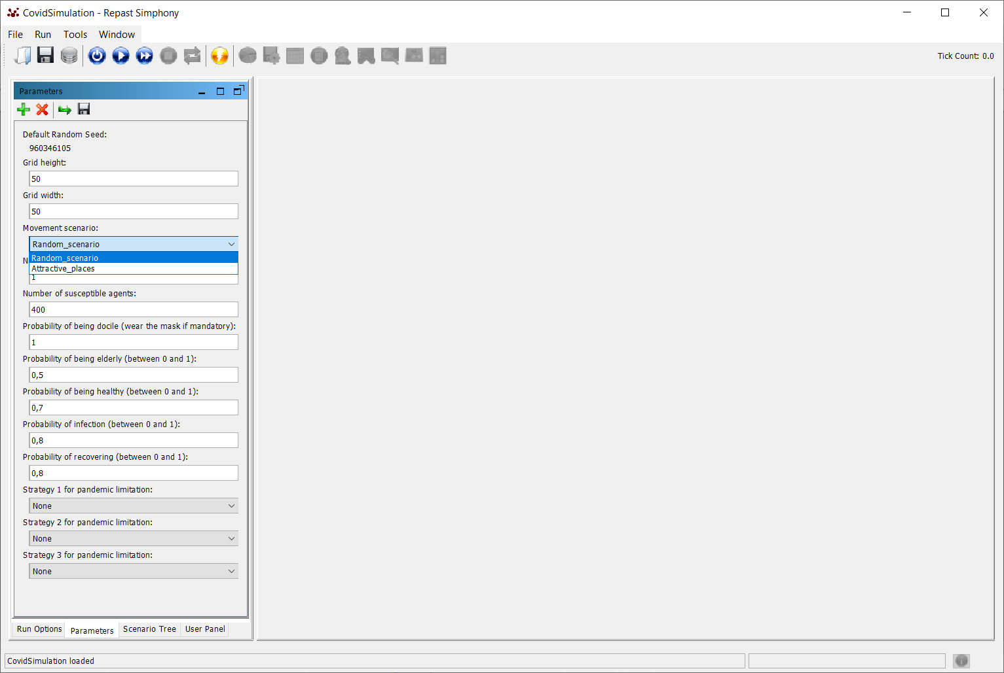
Then click on the arrow in the top list of buttons to run the simulation.
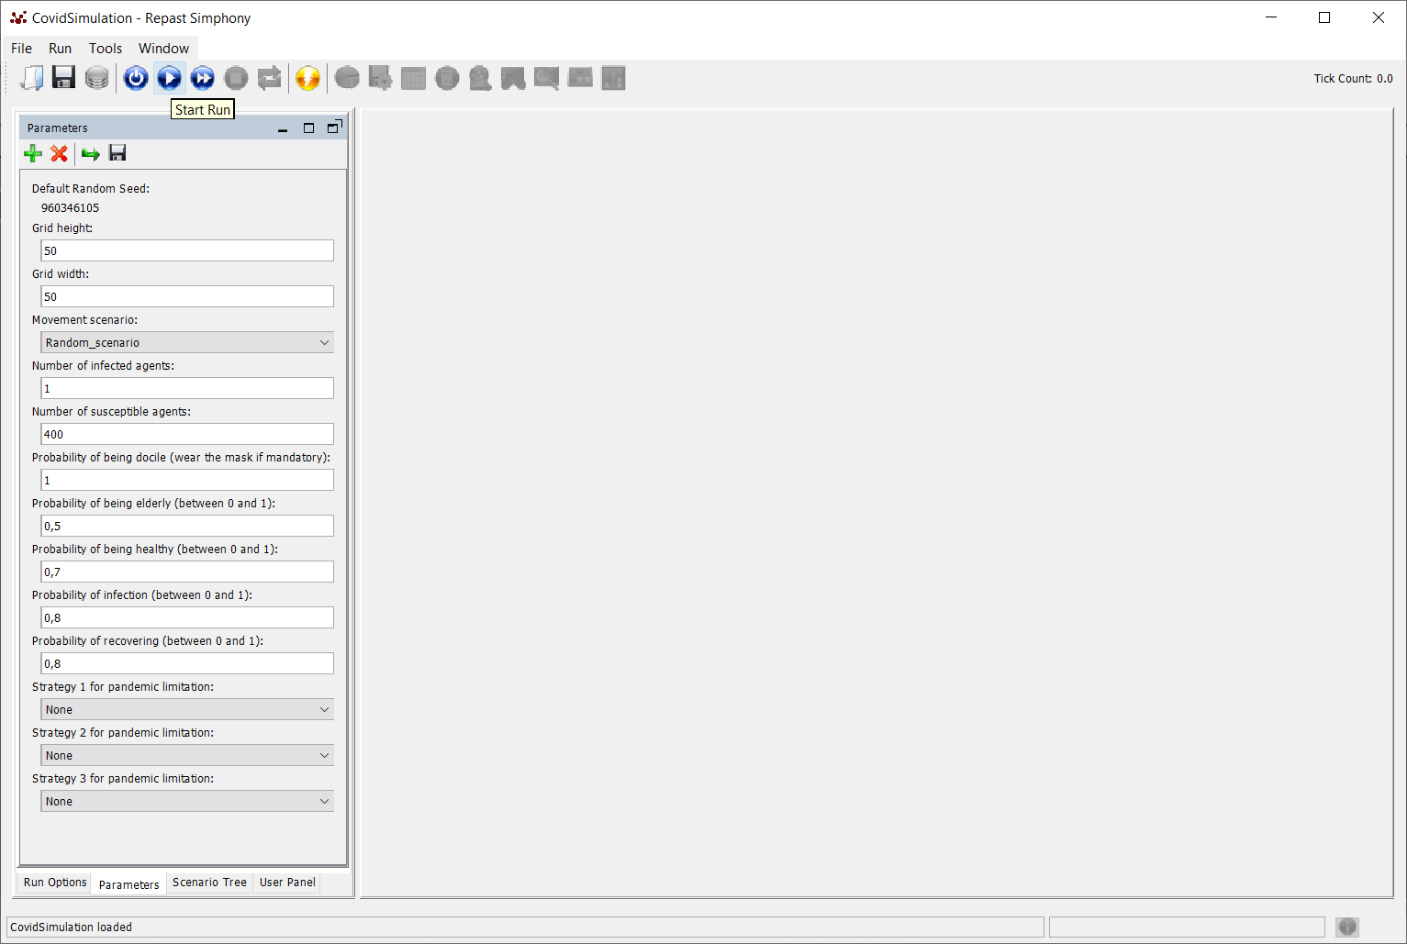
By default, you see the “CovidSimulation : Display 2D” simulation visualization.
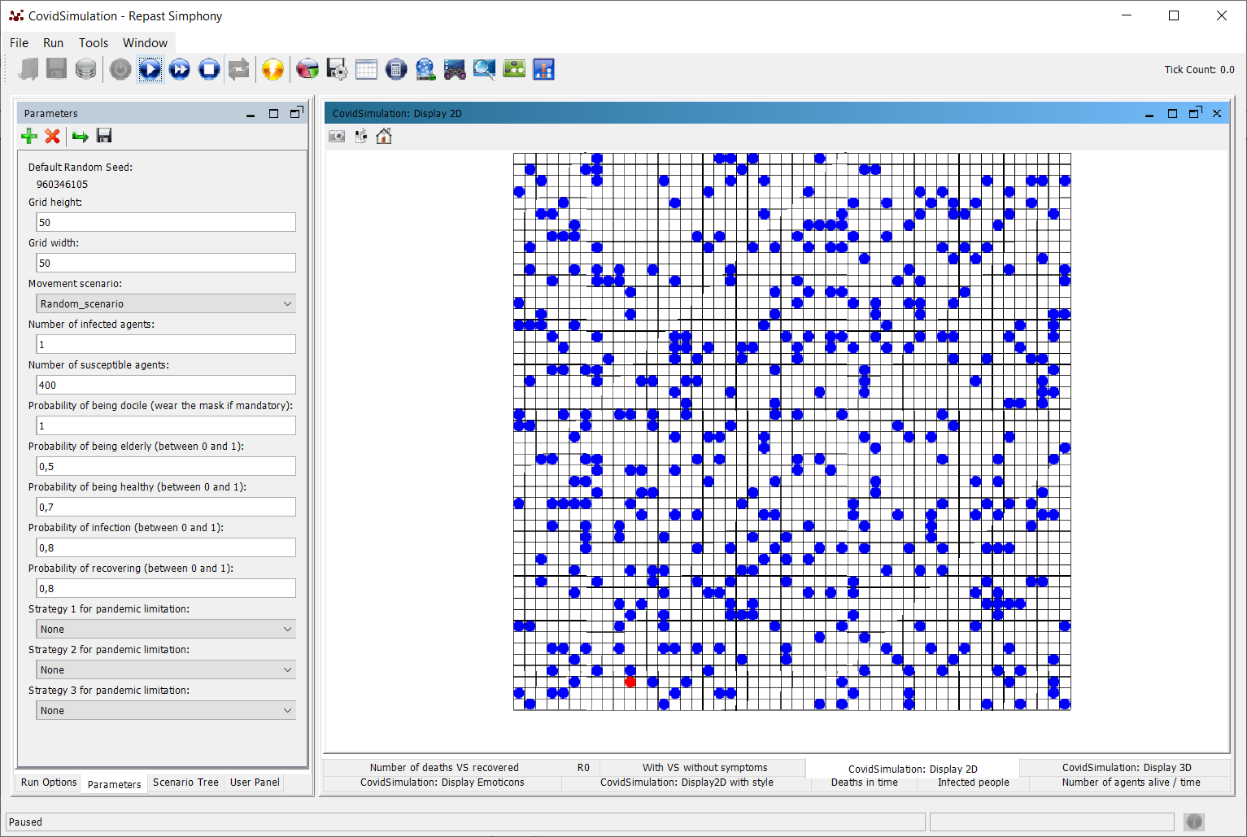
You can switch to 3 other visualizations by clicking in the tab under the simulation frame :
- the 3D visualization : “CovidSimulation : Display 3D” tab ;
- the visualization that uses a style class : “CovidSimulation : Display2D with style” tab ;
- the visualization that uses icons to represent agents : “CovidSimulation : Display Emoticons” tab.

For example, if you select the 3D visualization, you will get this type of screen :
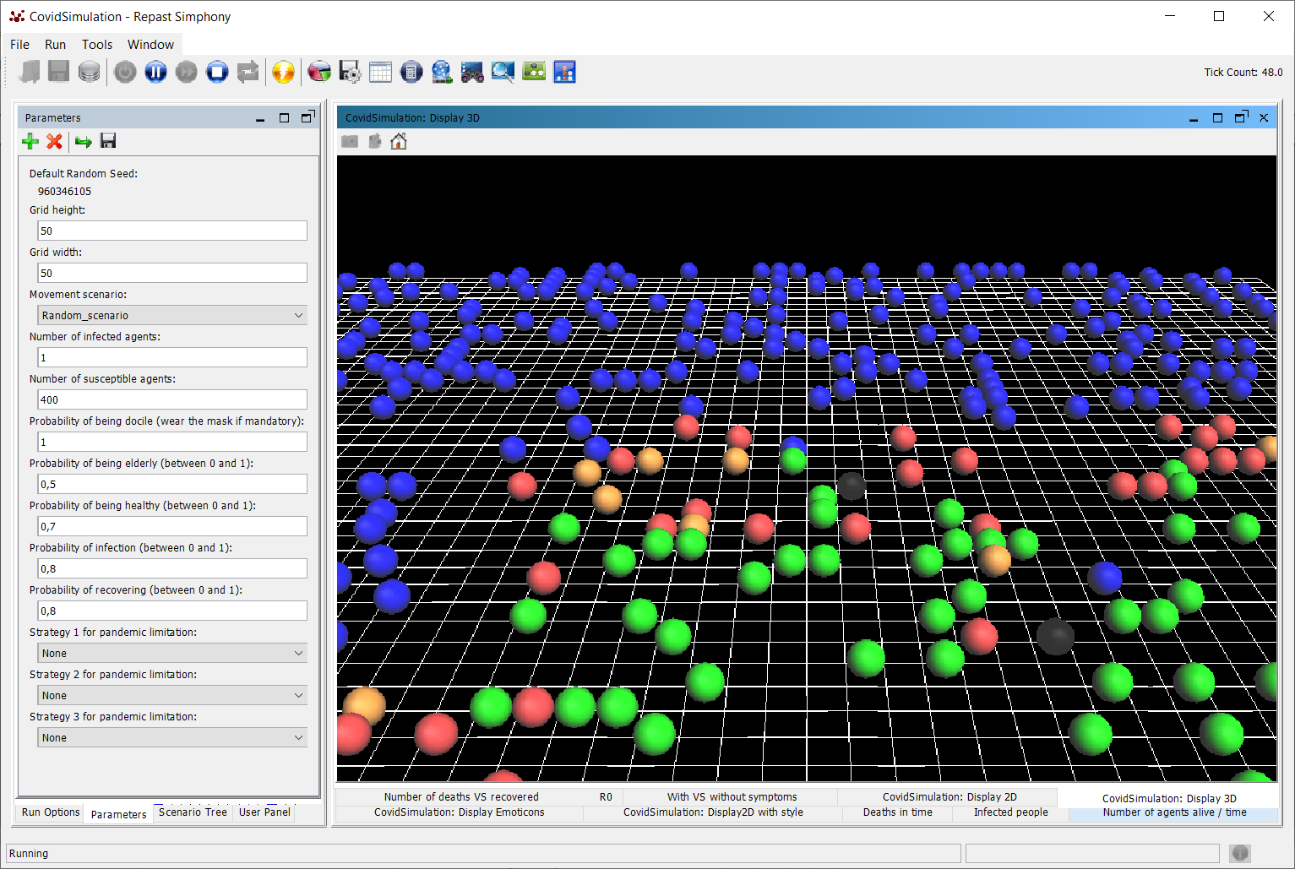

Then, you have different charts that give you information about the simulation :
- total number of deaths during the simulation : “Deaths in time” tab;
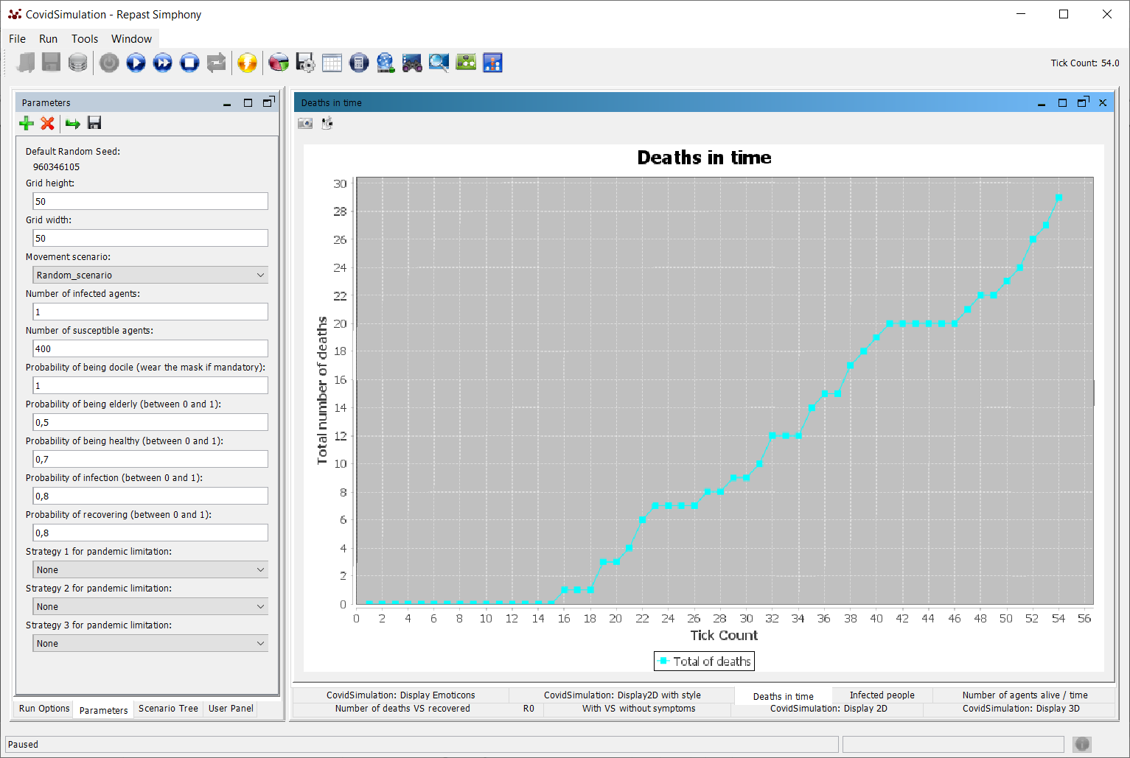
- number of infected people at a specific tick : “Infected people” tab;
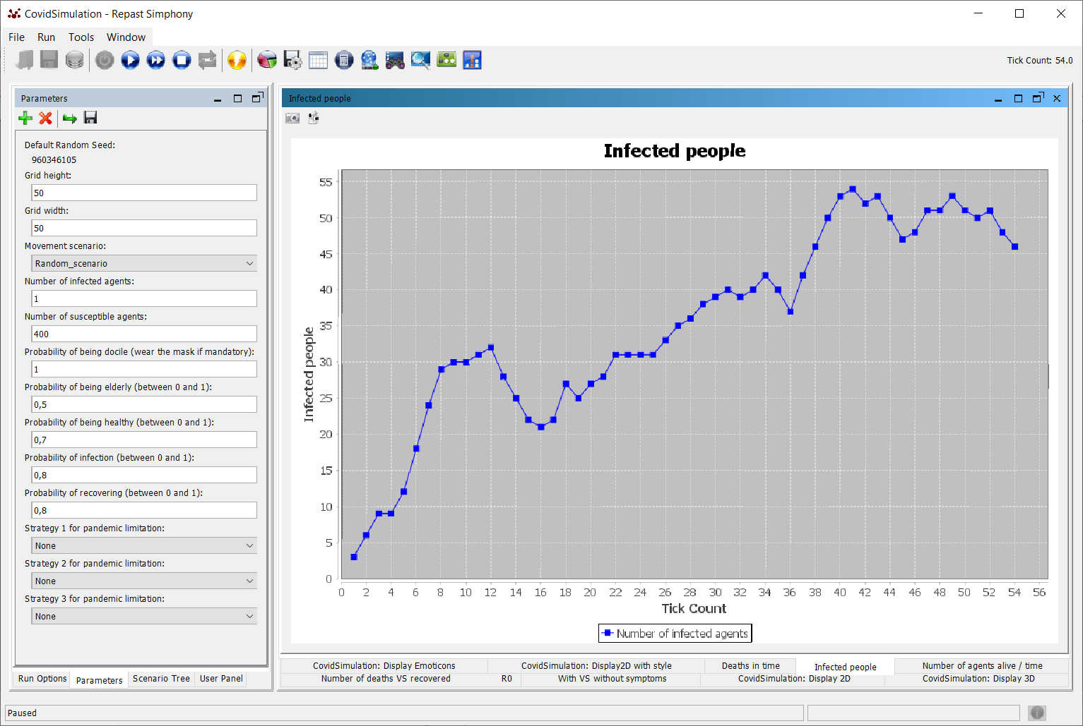
- total number of alive people during the simulation: “Number of agents alive / time” tab;
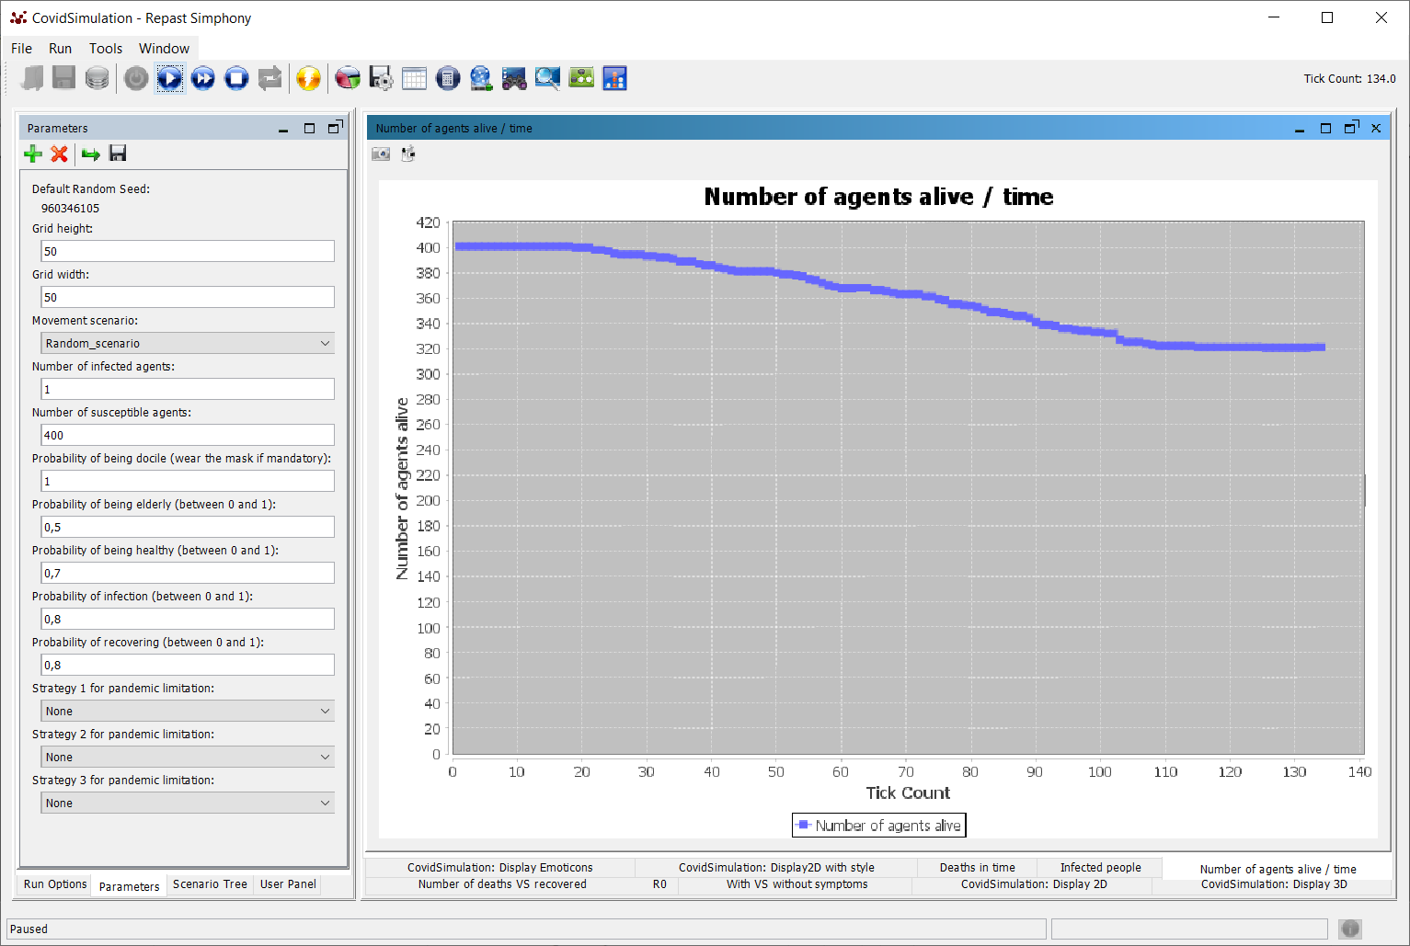
- comparison between the total number of deceased agents and the total number of recovered agents: “Number of deaths VS recovered” tab;

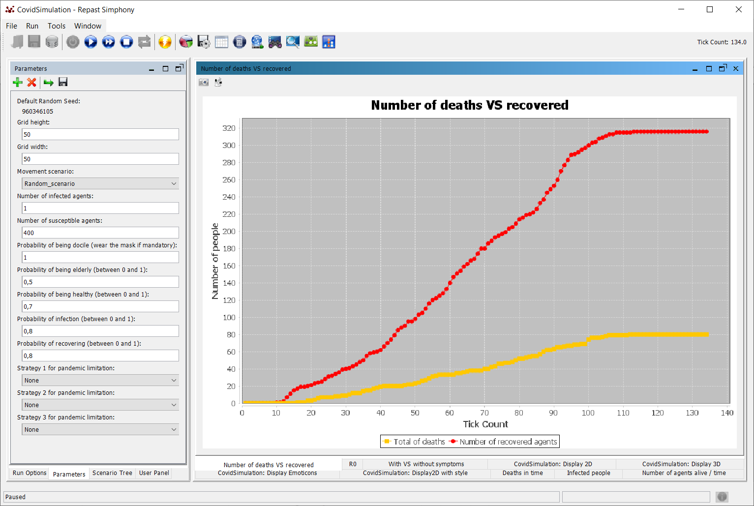
- comparison between the number of infected with or without symptoms: “With VS without symptoms” tab;
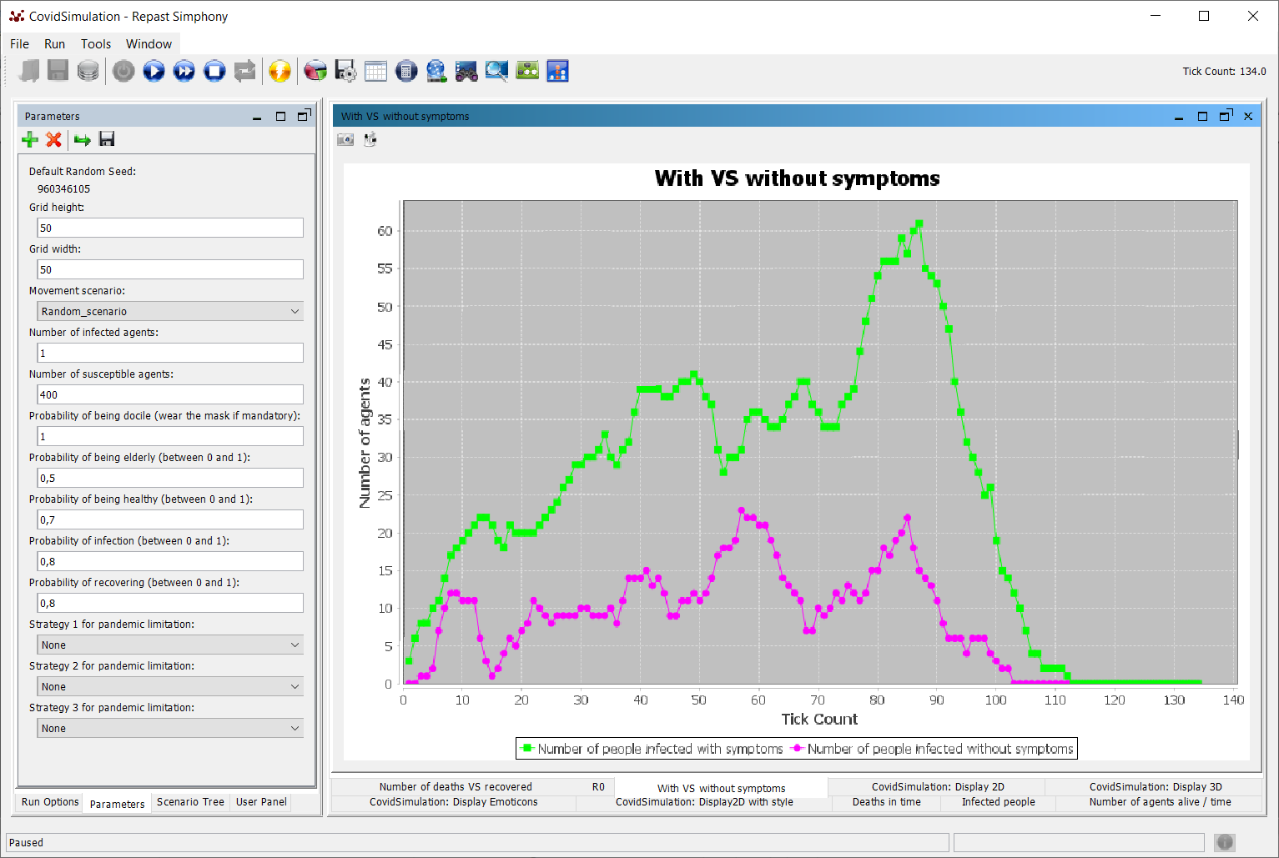

- incidence rate R0 (average of the number of people infected by one infected agent) : “R0” tab;

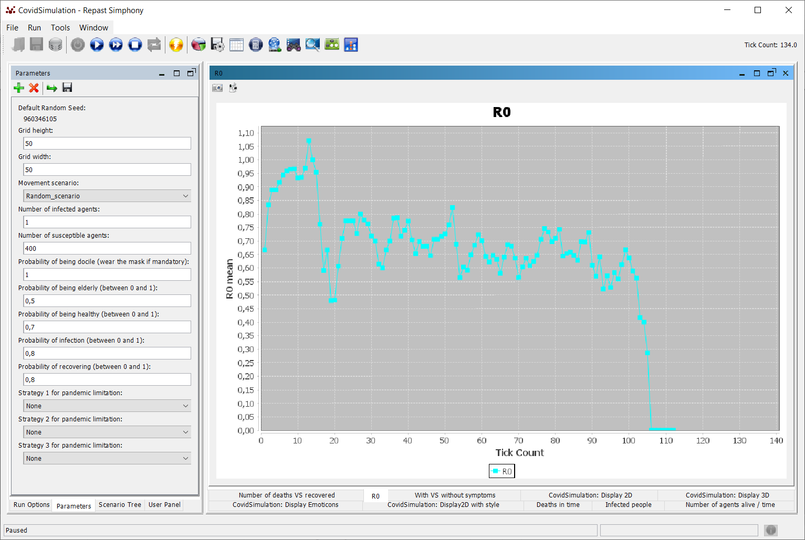
You can pause the simulation by clicking on the button. Then, just click again on the button to continue the simulation.
If you want to reinitialize the simulation, you have to stop it by clicking on the button and then
reset the run by clicking on the button.
Be careful : it will set all the default values for the parameters. Thus, if you want to run again with the same parameters than previous simulation, you need to reset them.

